**WEEK - 5**

**Microservices with Spring Boot 3 and Spring Cloud**

1. **Creating Microservices for account and loan:**

**Code:**

**ApplicationController.java:**

package com.cognizant.account.controller;

import org.springframework.web.bind.annotation.*;

import java.util.*;

@RestController

@RequestMapping("/accounts")

public class AccountController {

@GetMapping("/{number}")

public Map<String, Object> getAccount(@PathVariable String number) {

Map<String, Object> response = new HashMap<>();

response.put("number", number);

response.put("type", "savings");

response.put("balance", 234343);

return response;

}

}

**AccountApplication.java:**

package com.cognizant.account;

import org.springframework.boot.SpringApplication;

import org.springframework.boot.autoconfigure.SpringBootApplication;

@SpringBootApplication

public class AccountApplication {

public static void main(String[] args) {

SpringApplication.run(AccountApplication.class, args);

}

}

**LoanController.java:**

package com.cognizant.loan.controller;

import org.springframework.web.bind.annotation.*;

import java.util.*;

@RestController

@RequestMapping("/loans")

public class LoanController {

@GetMapping("/{number}")

public Map<String, Object> getLoan(@PathVariable String number) {

Map<String, Object> response = new HashMap<>();

response.put("number", number);

response.put("type", "car");

response.put("loan", 400000);

response.put("ed", 3258);

response.put("tenure", 18);

return response;

}

}

**application.properties:**

spring.application.name=loan

server.port=8081

**Output:**

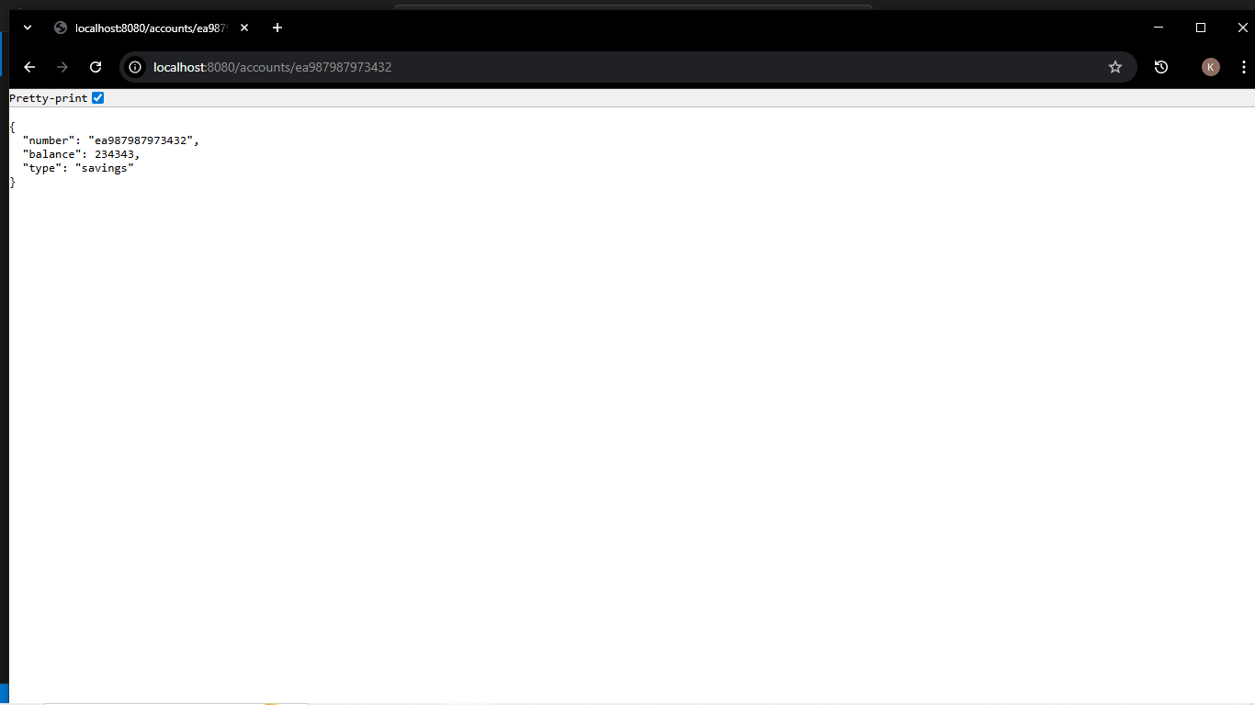

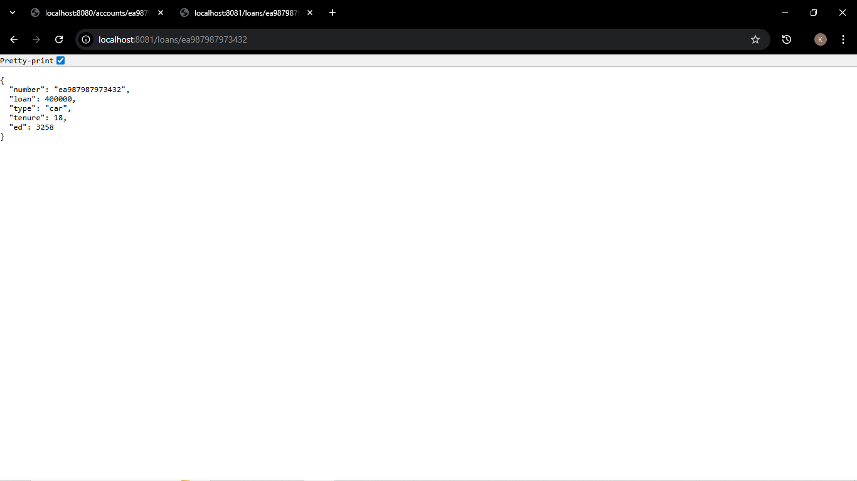

1. **Create Eureka Discovery Server and Register:**

**Code:**

**EurekaDiscoveryServerApplication.java:**

@EnableEurekaServer

@SpringBootApplication

public class EurekaDiscoveryServerApplication {

public static void main(String[] args) {

SpringApplication.run(EurekaDiscoveryServerApplication.class, args);

}

}

**AccountServiceApplication.java:**

@EnableDiscoveryClient

@SpringBootApplication

public class AccountServiceApplication {

public static void main(String[] args) {

SpringApplication.run(AccountServiceApplication.class, args);

}

}

**LoanServiceApplication.java:**

@EnableDiscoveryClient

@SpringBootApplication

public class LoanServiceApplication {

public static void main(String[] args) {

SpringApplication.run(LoanServiceApplication.class, args);

}

}

**Output:**

